ONLINE AUCTION / BIDDING SYSTEM

MINI PROJECT REPORT

Submitted By
Nataraj Divakar

Department
Bachelor of Technology (B.Tech)

College
Annamacharya Institute of Technology and Sciences, Tirupati

ABSTRACT
The Online Auction/Bidding System is a web-based application that enables users to participate in auctions through an online platform. The system allows users to register, log in, view available products, place bids, and track the highest bid in real time. This project eliminates the limitations of traditional auction systems by providing transparency, convenience, and accessibility. The application is developed using Flask, Python, MySQL, HTML, and CSS.

1. INTRODUCTION
Online auctions have become increasingly popular due to the rapid growth of e-commerce and internet technologies. Traditional auction systems require physical presence and manual management, which can be time-consuming and inefficient.
The Online Auction/Bidding System provides a digital platform where buyers can bid for products from any location. The system automatically records bids and determines the highest bidder, ensuring fairness and transparency.

2. PROBLEM STATEMENT
Traditional auction systems face several challenges:
- Requirement of physical presence.
- Manual bid tracking.
- Lack of transparency.
- Time-consuming processes.
- Limited accessibility.
The proposed system addresses these issues by offering a secure online platform for bidding and auction management.

3. OBJECTIVES
The main objectives of the project are:
- To provide a platform for online auctions.
- To enable user registration and authentication.
- To allow users to place bids on products.
- To maintain records of bids in a database.
- To display the highest bid automatically.
- To improve transparency and accessibility.

4. TECHNOLOGIES USED

Frontend
- HTML
- CSS

Backend
- Python
- Flask Framework

Database
- MySQL

Development Tools
- Visual Studio Code
- MySQL Workbench

5. SYSTEM ARCHITECTURE

Architecture Flow
User → Web Interface → Flask Application → MySQL Database

Components

User Interface
Allows users to register, log in, add products, and place bids.

Flask Application
Handles business logic, routing, and communication between frontend and database.

MySQL Database
Stores users, products, and bid information.

6. DATABASE DESIGN

Users Table
Field | Type
id | INT
name | VARCHAR(100)
email | VARCHAR(100)
password | VARCHAR(100)

Products Table
Field | Type
id | INT
product_name | VARCHAR(100)
base_price | DECIMAL(10,2)

Bids Table
Field | Type
id | INT
product_id | INT
bid_amount | DECIMAL(10,2)
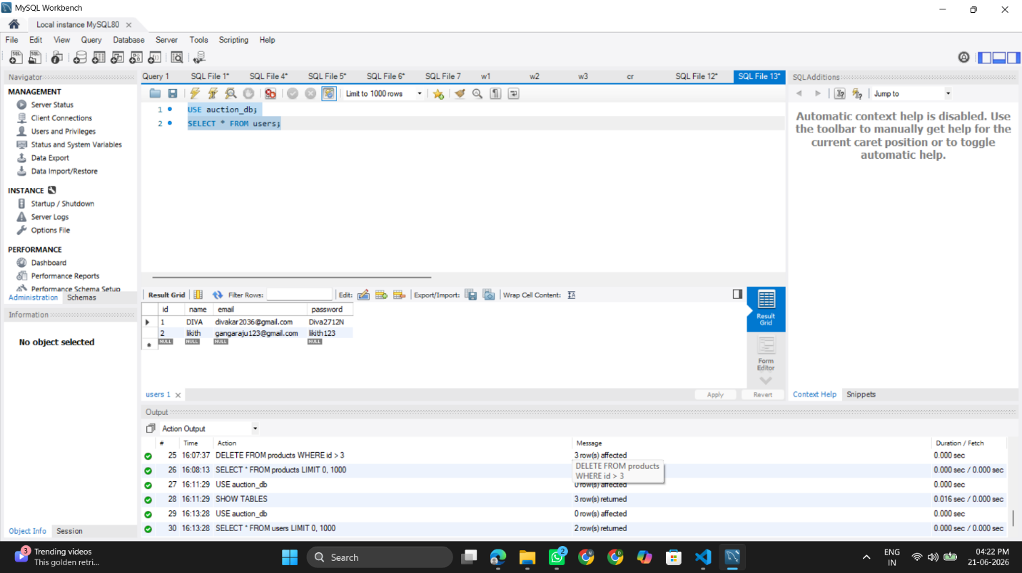

7. METHODOLOGY
The system follows the following process:
- User Registration
- User Login
- Product Listing
- Bid Placement
- Bid Storage in Database
- Highest Bid Calculation
- Winner Determination

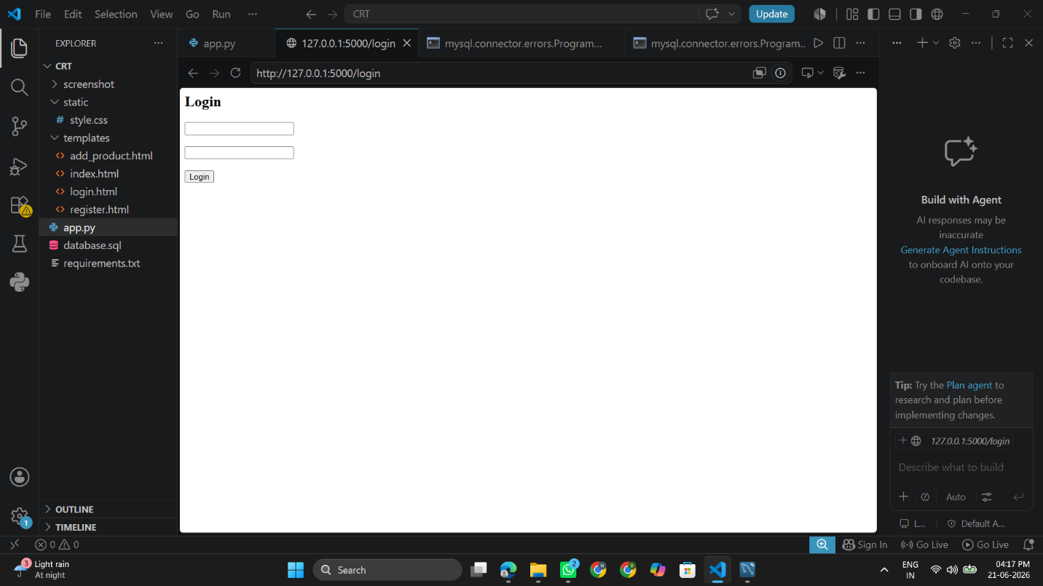

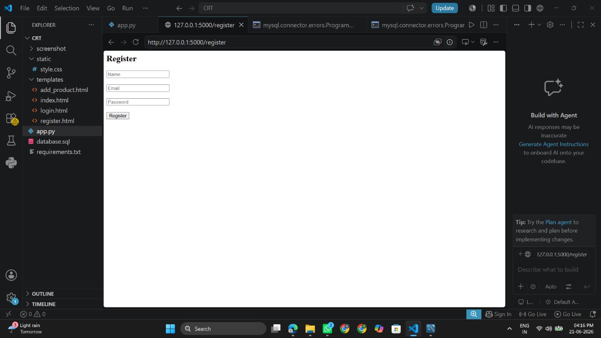

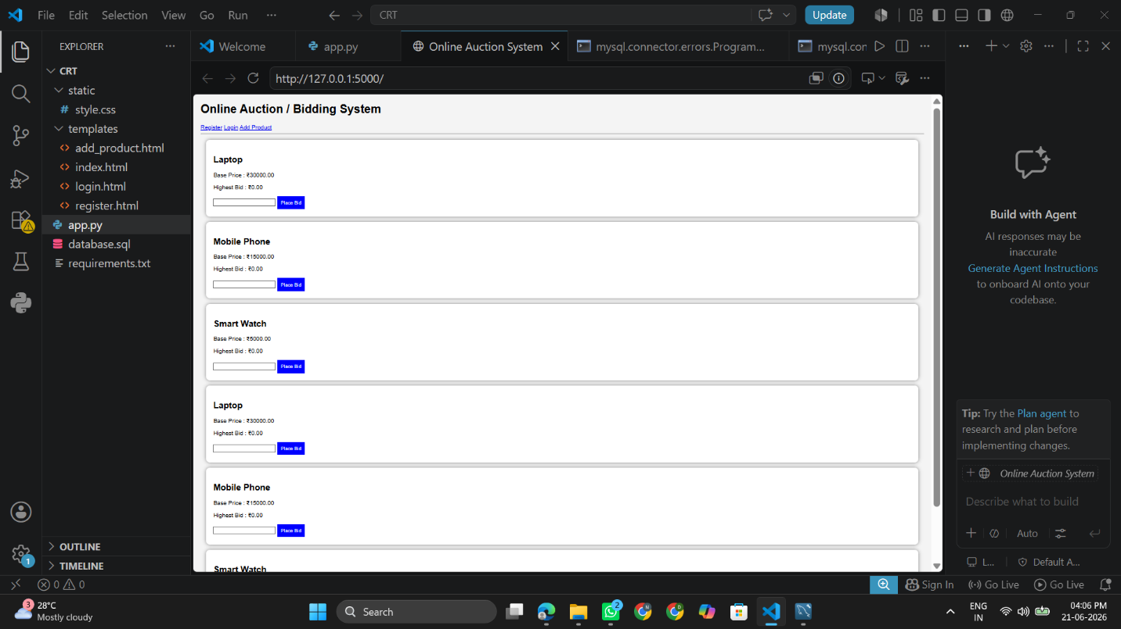

8. IMPLEMENTATION
The project is implemented using Flask and MySQL.

Features Implemented
- User Registration
- User Login
- Add Product
- View Products
- Place Bid
- Highest Bid Display
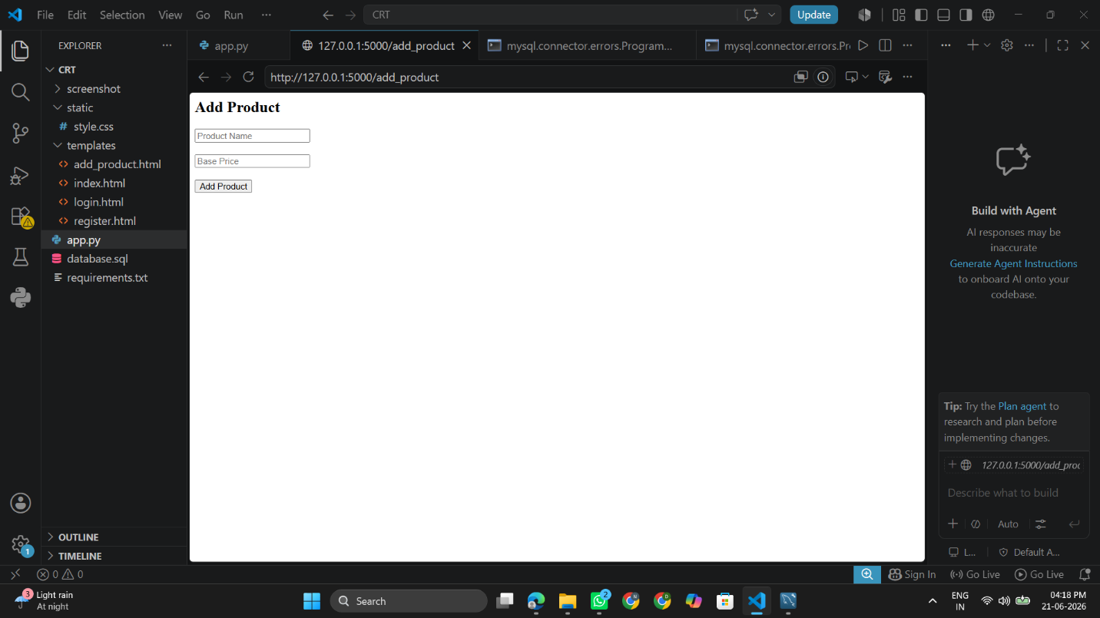
- Database Integration

Modules

Registration Module
Allows new users to create accounts.

Login Module
Authenticates registered users.

Product Module
Allows addition and display of auction products.

Bidding Module
Allows users to place bids.

Database Module
Stores and retrieves auction information.

9. RESULTS
The system was successfully developed and tested.

Output Achieved
- User registration works successfully.
- Login authentication works successfully.
- Products are displayed correctly.
- Bids are stored in MySQL database.
- Highest bid is displayed correctly.
- Database connectivity functions properly.
The project demonstrates a complete online auction workflow.

10. ADVANTAGES
- Easy to use.
- Real-time bidding.
- Secure database storage.
- Improved transparency.
- Accessible from anywhere.
- Reduced manual effort.

11. LIMITATIONS
- No payment gateway integration.
- No email notifications.
- Basic user interface.
- Local deployment only.

12. FUTURE ENHANCEMENTS
Future improvements can include:
- Online payment integration.
- Email and SMS notifications.
- Mobile application support.
- Product image uploads.
- Admin dashboard.
- Auction timer functionality.
- Winner announcement module.

13. CONCLUSION
The Online Auction/Bidding System successfully provides a platform for conducting auctions digitally. The system enables user registration, authentication, product listing, and bidding while maintaining records in a MySQL database. It improves transparency, reduces manual effort, and offers a convenient solution for online auctions. The project demonstrates practical implementation of web development technologies and database management concepts.

REFERENCES
- Python Documentation
- Flask Documentation
- MySQL Documentation
- HTML & CSS Documentation
- Visual Studio Code Documentation

